CEN 4010 Principles of Software Engineering Fall 2019

Milestone 1 Project Proposal and High-level description

FAU Daily

Team Number: 14

Mark Rothberg, Marcus Golding, Wayne Solomon

11/4/2019

History Table: 11/4/2019

**Executive Summary**

The following is a summary of a senior project to create a web system based on the Campus Snapshots project outlined and provided in the class but under the name FAU Daily.

This project aims to create a social/news environment to the benefit of campus life and recreation including upcoming events and real time updates as opposed to exclusively highlighting future events. It will also provide an avenue to report and bring attention to smaller scale issues around the campus which include, but are not limited to, overflowing trash, fallen branches, classroom issues, etc.

This website is primarily targeted to the entirety students with an attention to faculty. The goal is to provide an avenue for anyone to report issues with the campus or events.

**Competitive Analysis**

|  |  |
| --- | --- |
| Competitor: FAU Student News | Yours: FAU Daily |
| Upcoming events are posted | Upcoming events are posted as well as current events |
| Can RSVP with Handshake | Can RSVP with Handshake by linking to their website |
| The News is updated every day | The News is updated per minute |
| Posts threats and sends text messages to all students phones | FAU Students are able to post information regarding plumbing problems, construction problems, potential threats, or any dangers to alert other students. |

The planned advantages that FAU Daily has over the current Student News is that FAU Daily has updates per minute of everything that is going on at school. Anything that is slightly important will be posted on the website. When school starts all of the events will be posted on our front page and we will have a calendar of upcoming events. We will also have postings of people on campus such as the school performers that are playing in the breezeway or student organizations that are having events at that exact moment. This is dedicated for the student that doesn’t know about any event and wants to go to something in the moment.

**Data Definition**

The user will be able to access the website in order to view the news. The user will be able to make an account to post news onto the website. The profile of the user will have a spot for a picture of the user, a name slot, and the about section. If the user doesn't post a name for themselves they will be given a randomized number next to “FauUser #”. The user will be able to only edit their posts. The user will not be able to edit any other user’s post or any website information. So If someone posts *“Hellow World”*, another user won’t be able to edit it to say *“Hello World”*. The user won’t be able to edit what goes onto each page. The owner of the website will have full access to everything.

These are our definitions and acronyms that we use for our website.

FAU Daily: FD

News: Anything and everything that is occurring on campus

Database: The collective information of all the news stories.

Work in Progress: WIP

**Overview, Scenarios and use Cases**

This project will emphasize the needs and wants of the average FAU student ranging from the technically savvy to those who are not all too familiar with sites outside of social media. The goal is to be accessible to those who see an issue and are looking to quickly report it. Those who are interested in various events around campus will be able to quickly and efficiently locate said events without requiring any navigation.

Users will create an account using their FAU email (preferably) and a password in order to submit a post to the complaints board. Viewing will not require a password. The home page will contain a timeline of upcoming events. There will be a dedicated page for a calendar of events

**High-Level functional Requirements**

1) Home/Front page with currently updating news on the top and on the sides are upcoming news events and stories. The User will be able to access the home and the front page to view the news. The User will be able to post to the front page. The User will only be able to edit their post and will be able to update it as needed.

1) A login for FAU students using a separate username and password. The User will be able to make an account for the website in order to post to the site.

2) Calendar Page: A calendar with all of the upcoming events. The User will be able to view the Calendar Page, and after approval from the Administrators/Owner, will be able to post an event.

2) A separate page for Student Organization events. The User will be able to view this site. Only the Designated Administrator or Student Organization member will be able to edit this page.

3) A meeting page dedicated to people who don’t have many friends and want to meet more people in the same field. The User will be able to view this page and chat with all of the other users. The User will be able to post whatever they want that is within School guidelines.

**List of non-functional requirements**

The system will allow the user to use Internet Explorer, Mozilla Firefox and Google chrome. There won’t be a dedicated mobile version of the website. There shouldn’t be too much of a load on the server. There will be relatively secure accounts with password management. The website will be stored on the lamp servers. The website will be available as long as the server will host our group. There will be some code safe guidelines if there are any faults.

**High-level system architecture and database organization**

We will be using Visual Studios, Sublime, Atom, Java, JavaScript, HTML, CSS and C++. We will support Google Chrome, Internet Explorer, and Mozilla Firefox. We will mainly use CSS and html. Any external code that we would use would be from YouTube, general coding help sites or bootstrap.

The main features that are apart of this project can separated into 4 categories being the accounts, live updates, posts and timeline. The accounts will require a server to hold them all. To accomplish this, we can use the lamp server given to us by Florida Atlantic University. To classify a login, the user must define a username, password. The user will have an addition option to add a picture to their account if they choose to do so. For live updates and post, we can use a simple interface similar to other social media and blog sites. The post can only be made by users with accounts and each post will have a reply section paired with a like button. The post or blog will have a text and/or picture entry. Lastly, the timeline will be all the posts that have been either recently made or the most popular indicated by the number of likes.

Log in

Lamp server

Username and password

Picture

Live update

Post format

User to post

Reply section

Like section

Post section

Picture

Text

Timeline

Most liked or most recent at the top

**High-Level UML Diagrams**

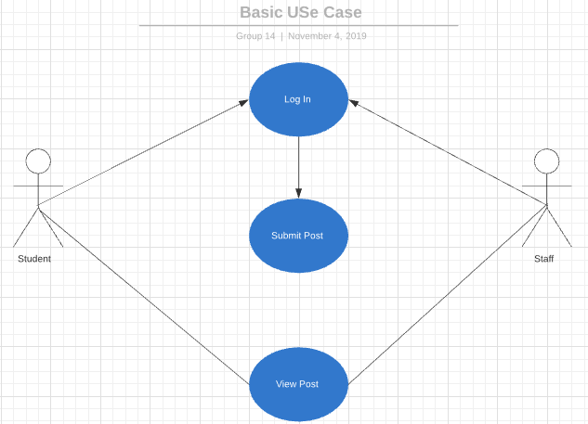

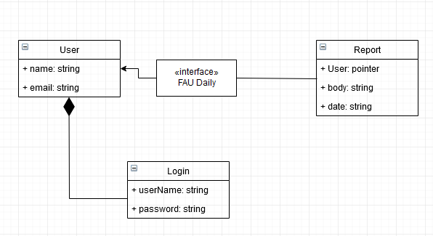  
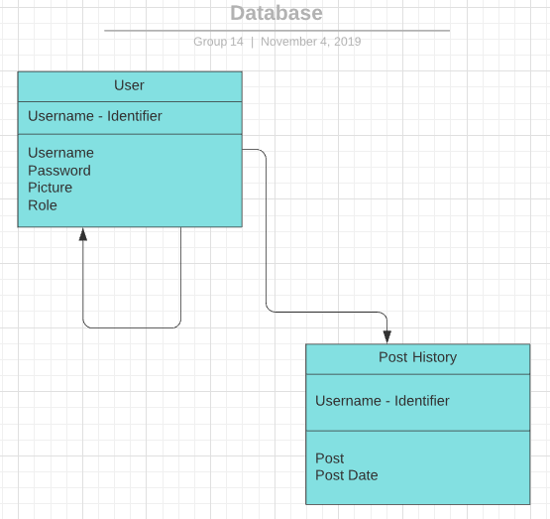

**Identify actual key risks for your project at this time**

1. Skill risks: There shouldn’t be able risks for the User. The User will have to be able to use the Internet. The User will also have to understand how to Post onto the website. In order to show the User how to post on the website, there will be a help tab which will explain exactly how to post onto the website. There will also be pictures displaying each step.
2. Schedule Risks: The only problem that would arise is for the Calendar page and Student Organization Page. The Administrator will have to check the webpage for anyone who wants to post to the Calendar. The Administrator will also have to be in contact with the Student Organization in order to post to that page with relevant information. In order to fix this, the website will be able to send an email to the Administrator for every request from the User. The Administrator will be able to enable permission from the email for the post of the User.
3. Technical Risk: There shouldn’t be any Technical Risks that involve this assignment. The only problem that could possibly arise would be that there could be a power outage that requires the website to be updated. If this were to occur the solution would be that within the code there will be a failsafe. The failsafe will be activated and the website would be reset as soon as the server is put back online. This would be a server side risk which the Owner of the website wouldn’t be able to do much about since the website is hosted on a Lamp server.
4. Teamwork Risks: This team has great teamwork and has shown to be able to work very well under pressure. This team doesn’t have any problems so far with teamwork. In order to solve any problem regarding teamwork, the team would meet with the Leader of the section to discuss the problem. Once the problem has been understood the Leader would handle the situation.
5. Legal/content Risks: The only risk would be the fact that this website will be competing with Fau Student News. Even though we are posting different information from them, they might think we are copying their website. In order to solve this problem we can change up more of the website, but we aren’t using anything that they have. The entire backend of the website is also different from theirs so they can’t copy strike this website.

**Team Member participation Form**

These Members have participated in every aspect of the assignment Mark, Marcus and Wayne